Opening Browser and navigating to the URL

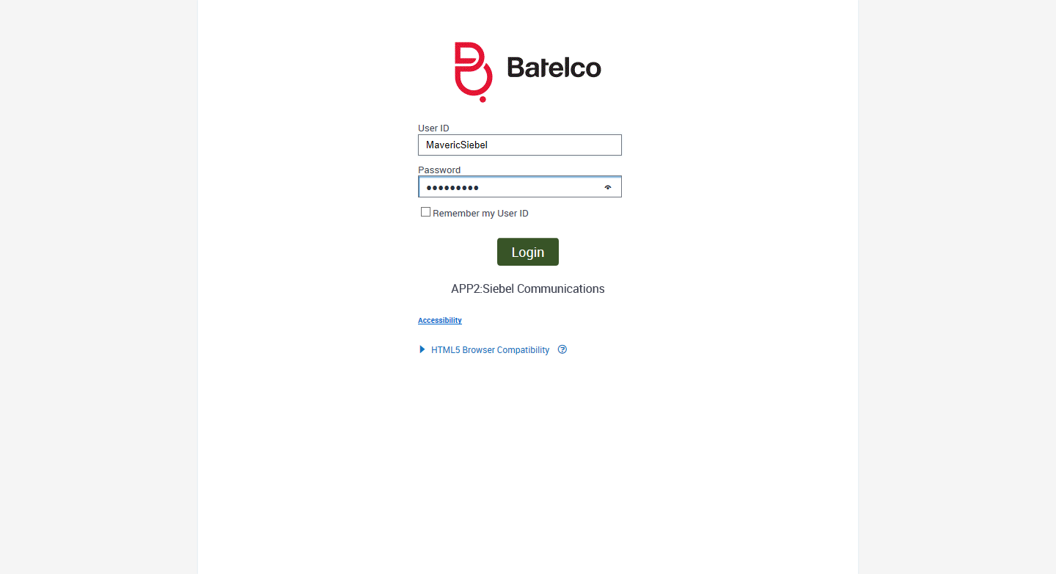

Clicked On Accounts Tab

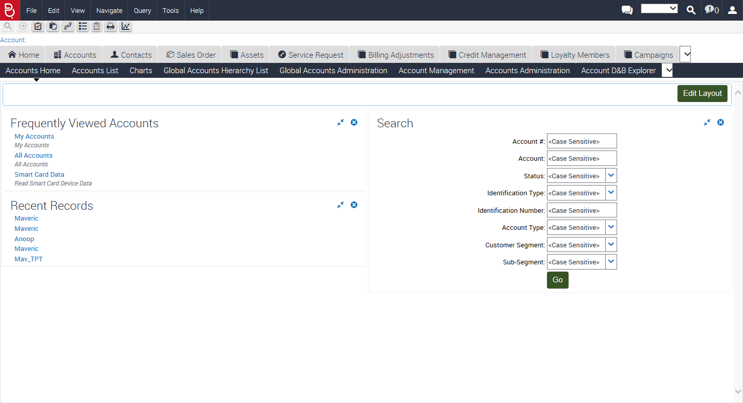

Entering Identification Number to Get the Account: 2002181719

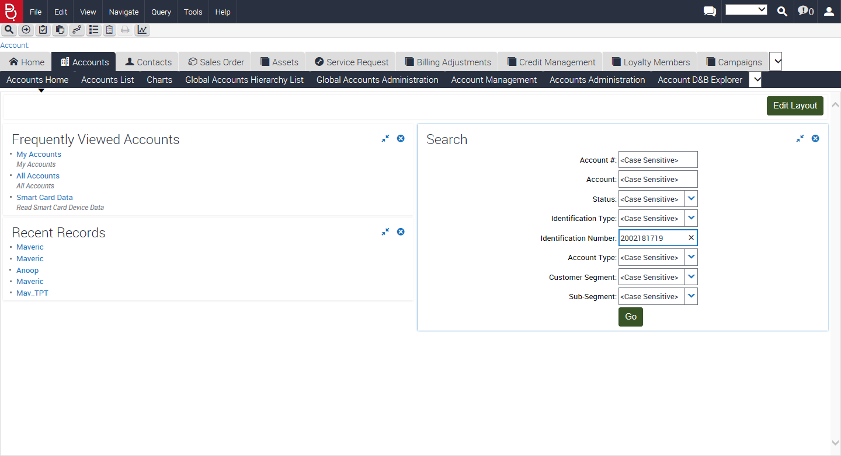

Clicked On Search Go

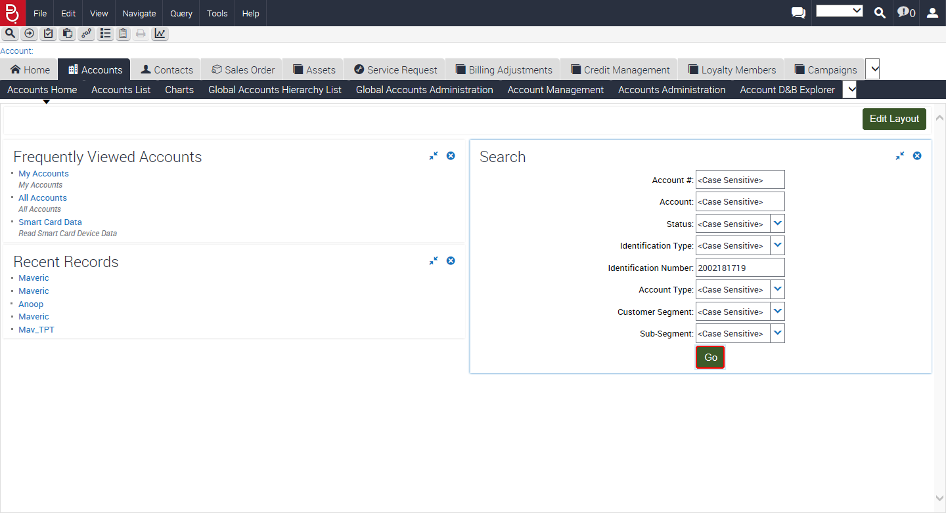

Entering into the Account

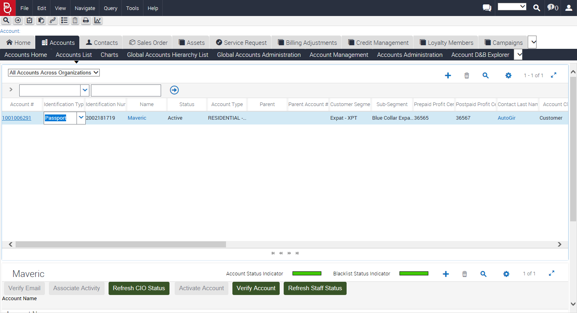

Account Number: 1001006291 and Name: Maveric

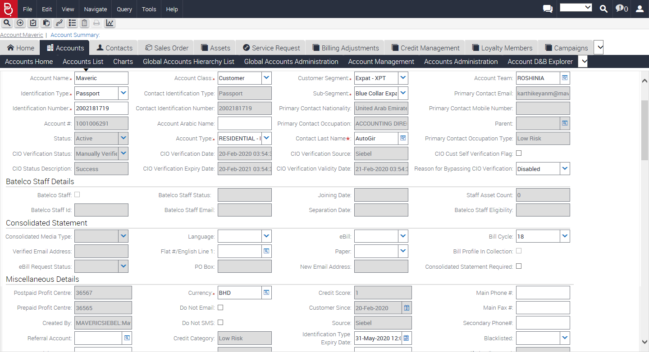

Installed Assets

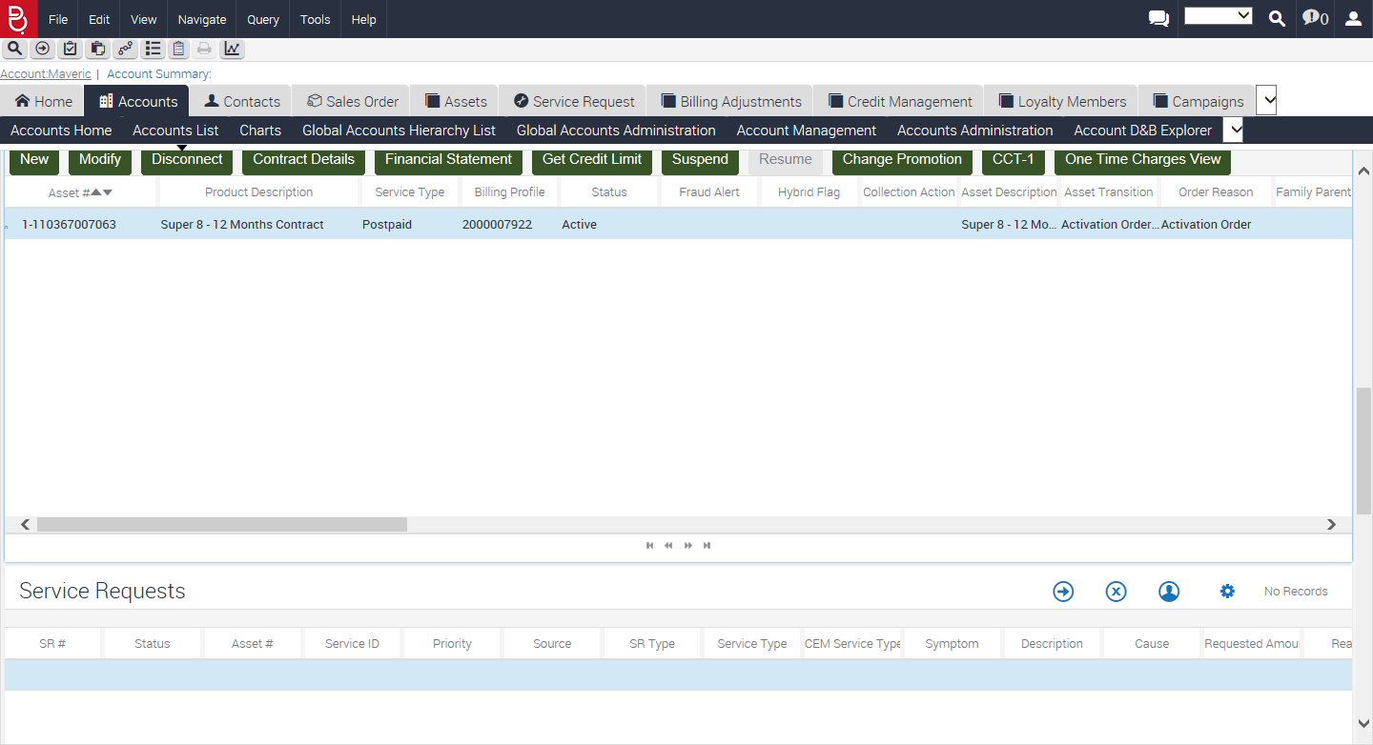

Clicked On Change Promotion

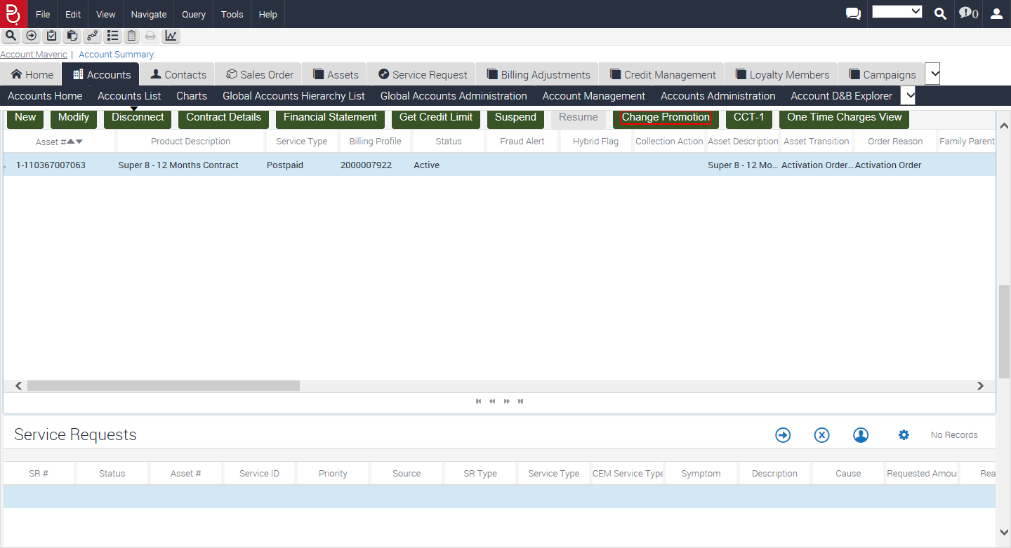

Entered Downgrade as Order Journey Reason

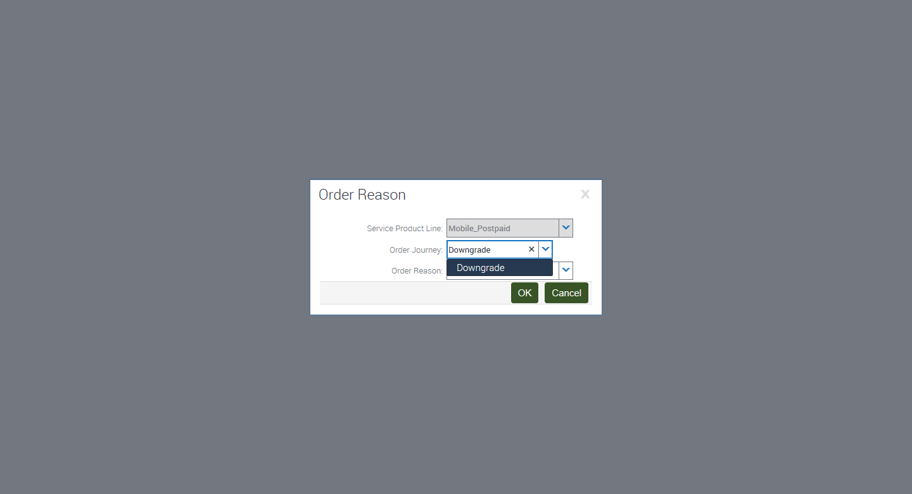

Entered Post to Pre as Order Reason

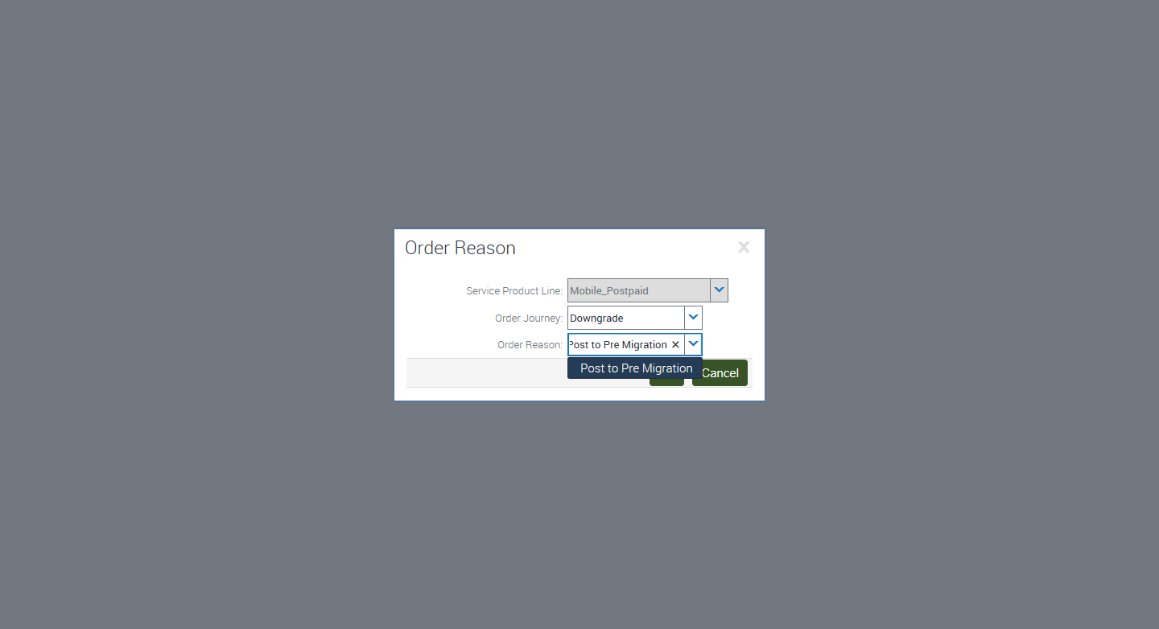

Clicked On Ok button

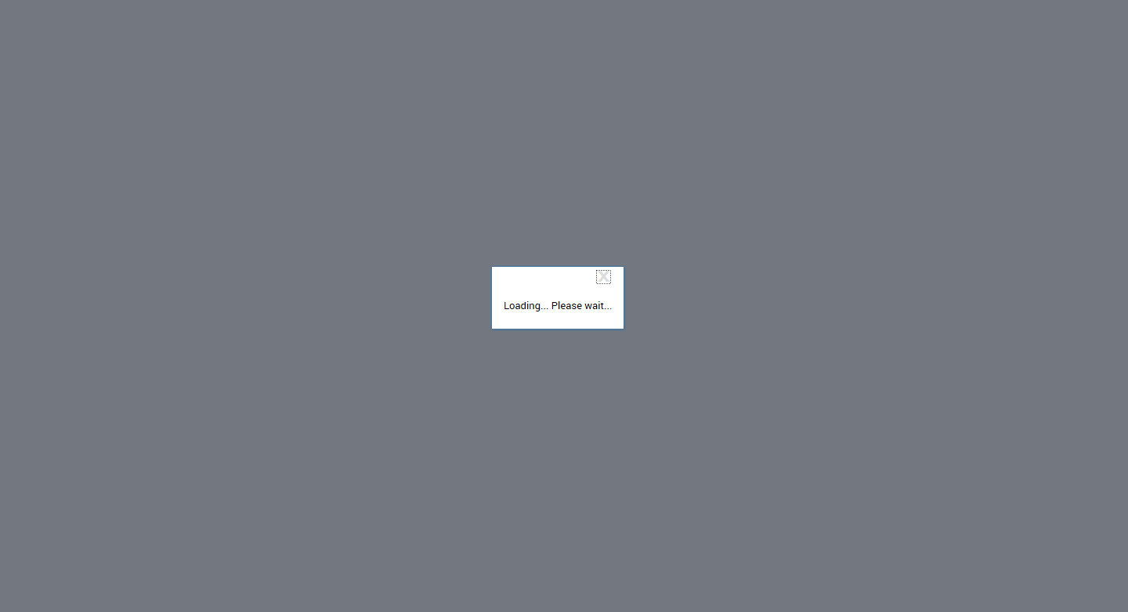

Clicked On Downgrade

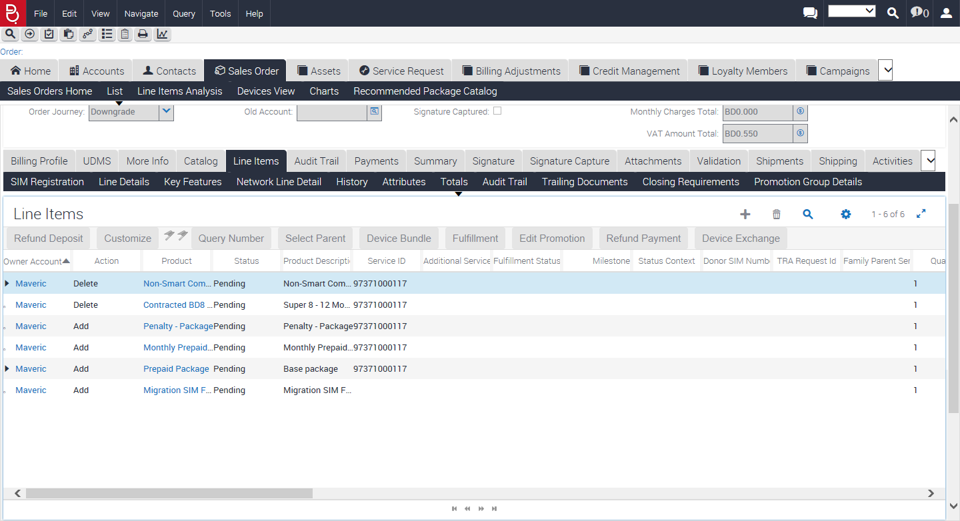

Clicked On Change Package Expand Tree Icon

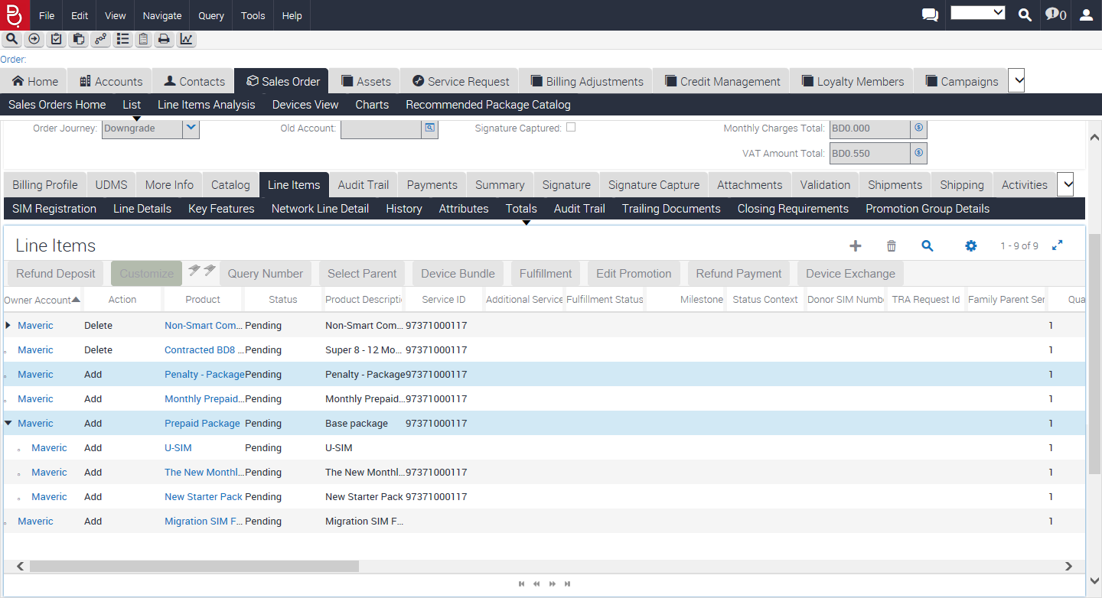

Entered SIM Number8999999200027860059

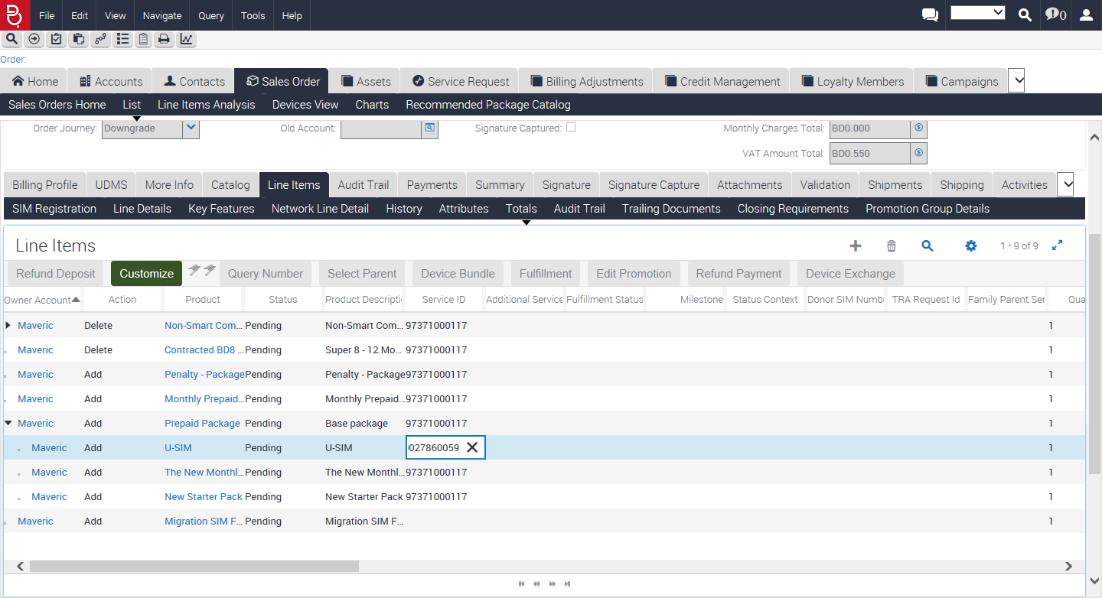

Clicked On Save Record

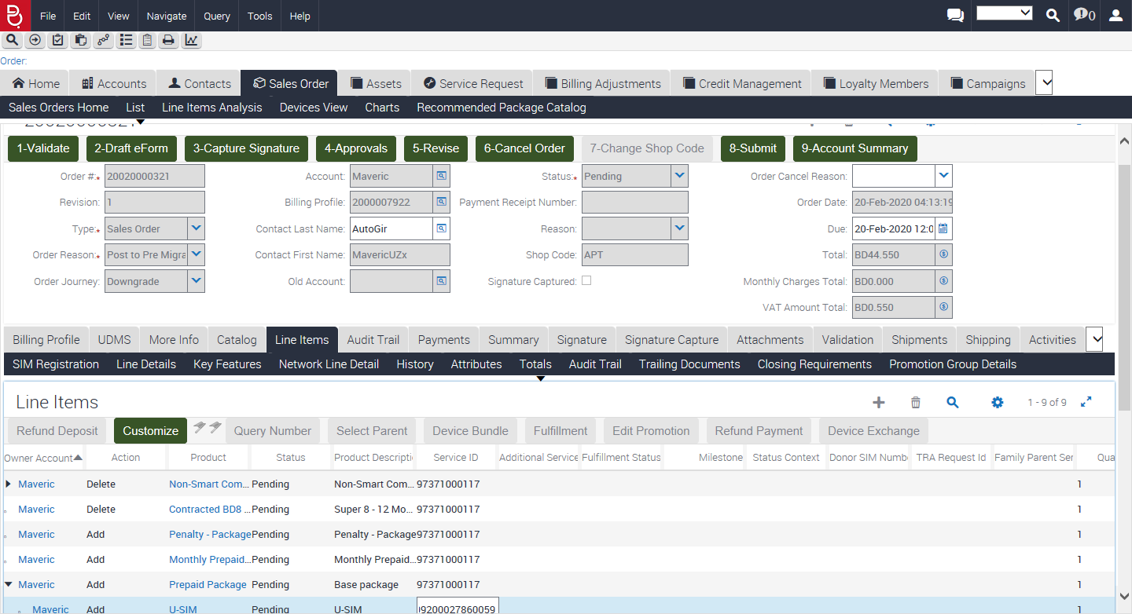

Clicking on Create Payment

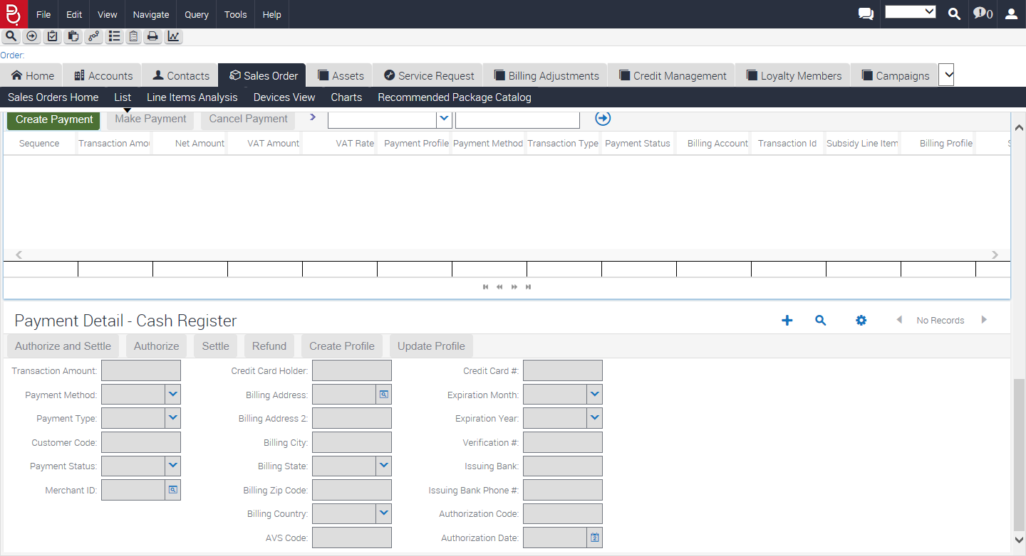

After Payment: Paid

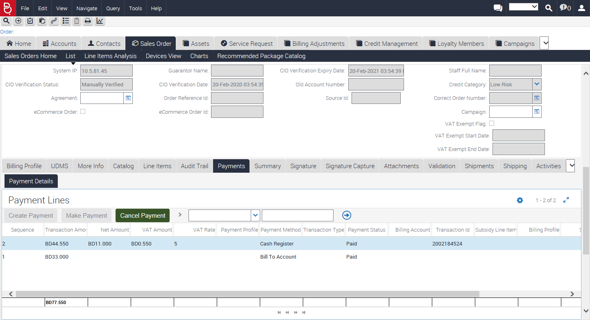

Cliked On Save Record

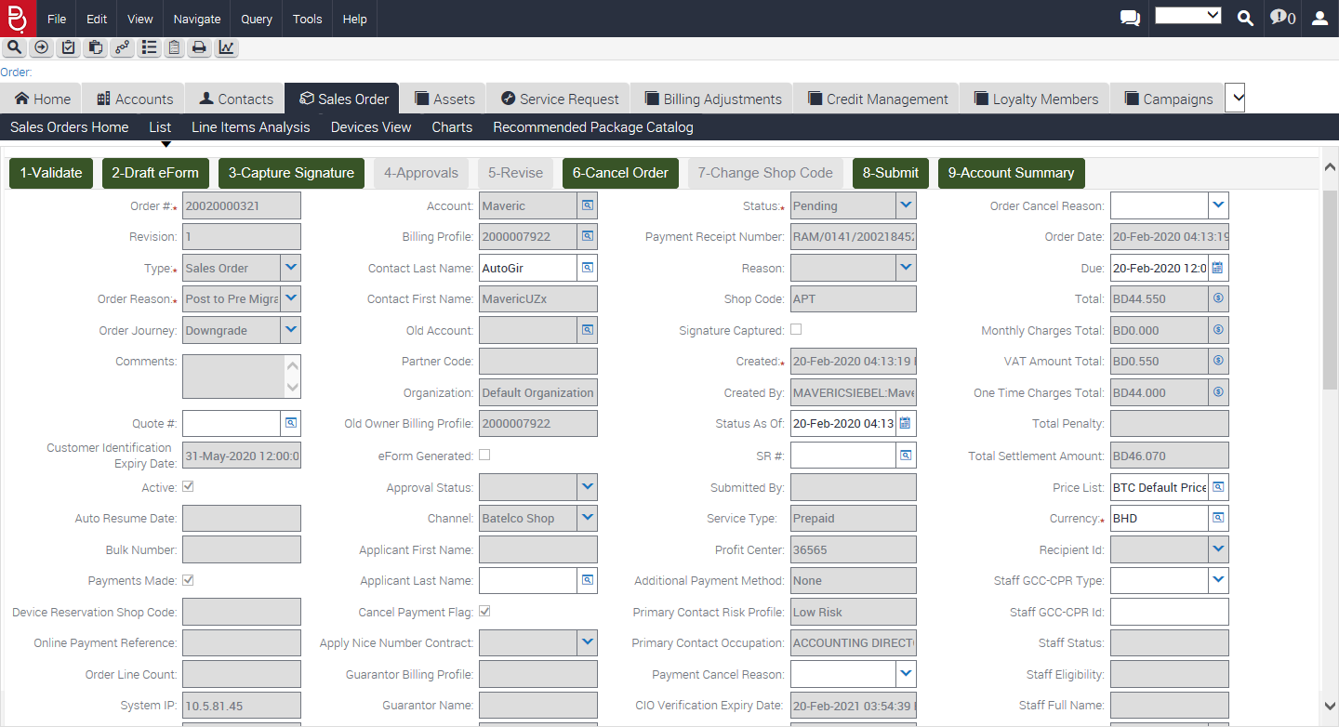

Clicked On Validate

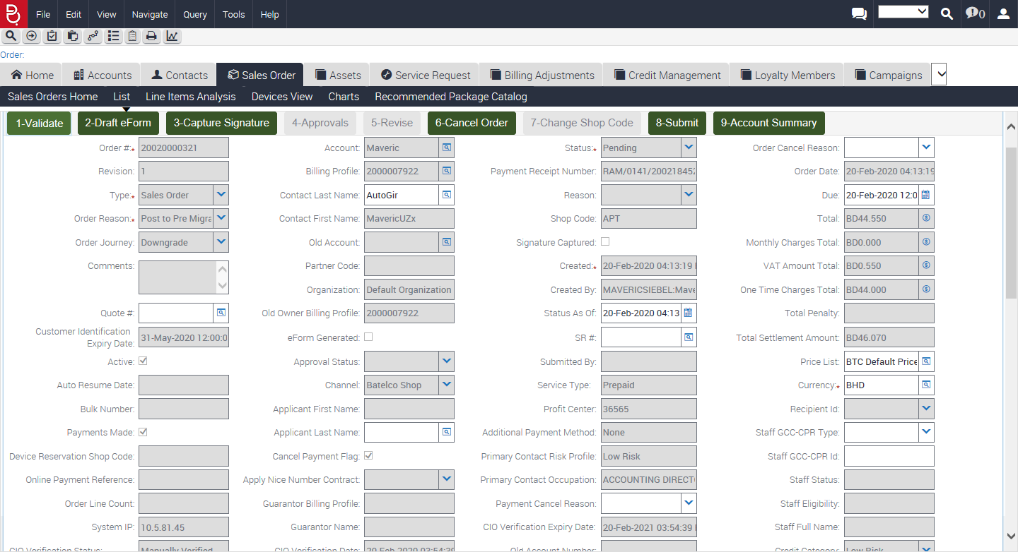

Signature Captured

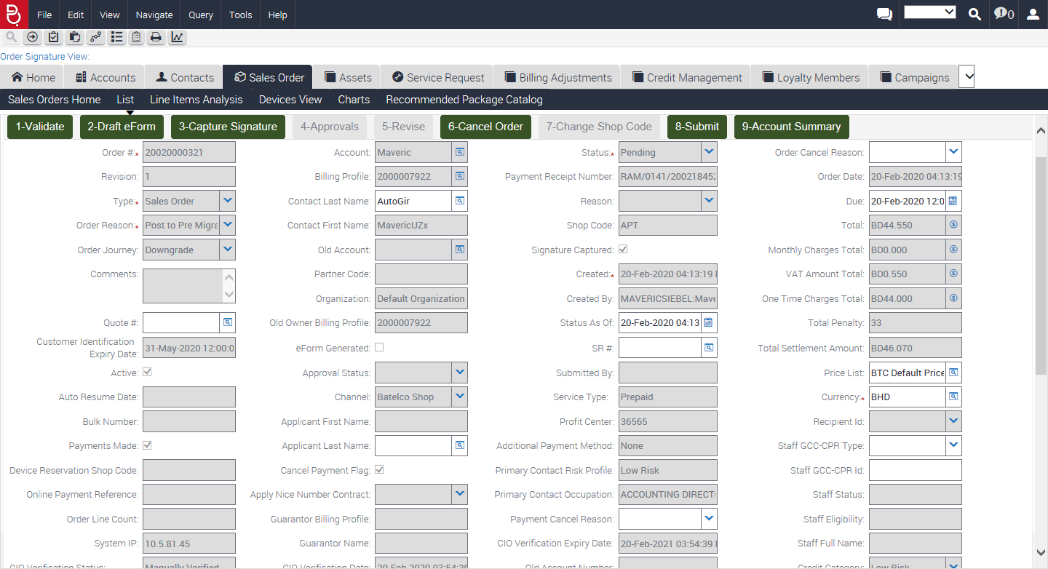

Clicked On DrafteForm

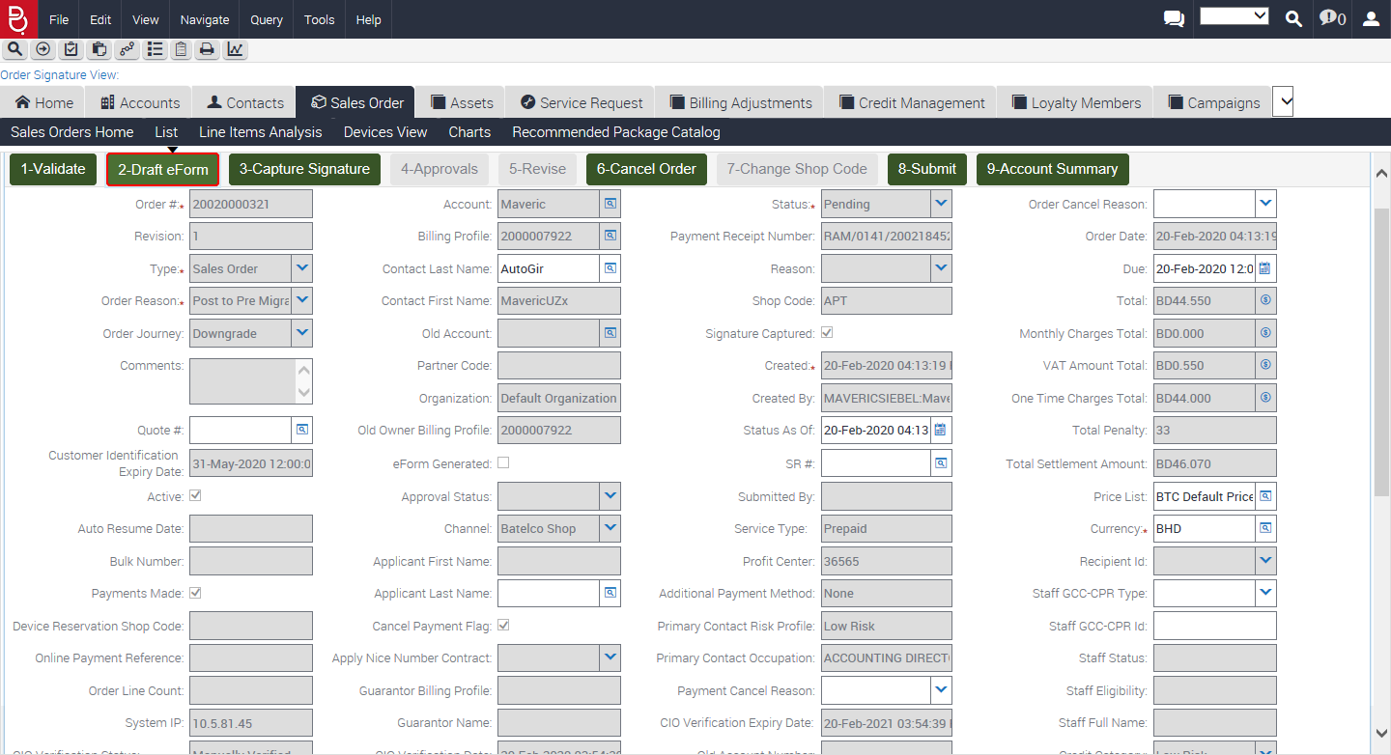

Newly Installed Assets after Order Submission

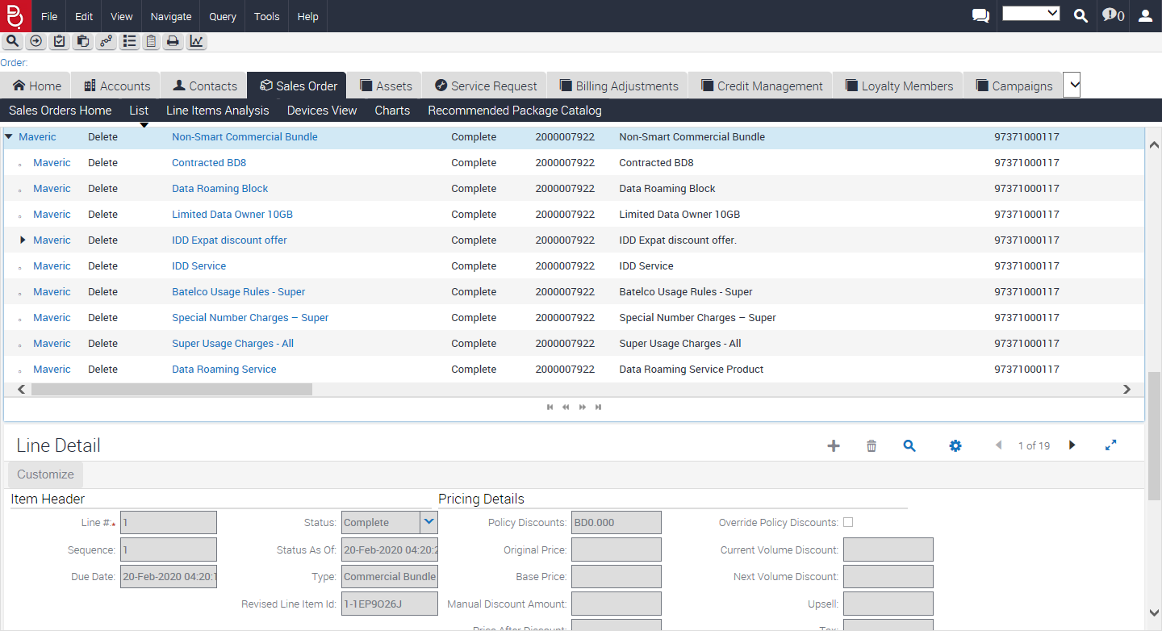

After Refreshing the Browser Order Status: Complete and Order Completion Time: 1 minutes, 23 seconds.

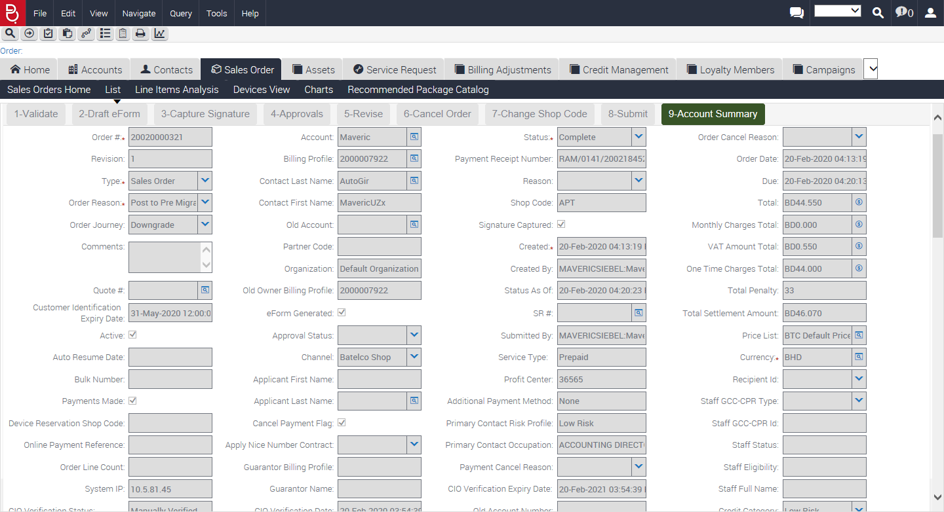

Clicking on Account Summary button

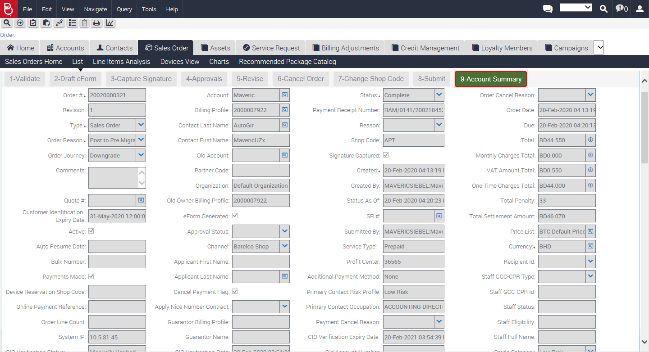

Account Summary Detail

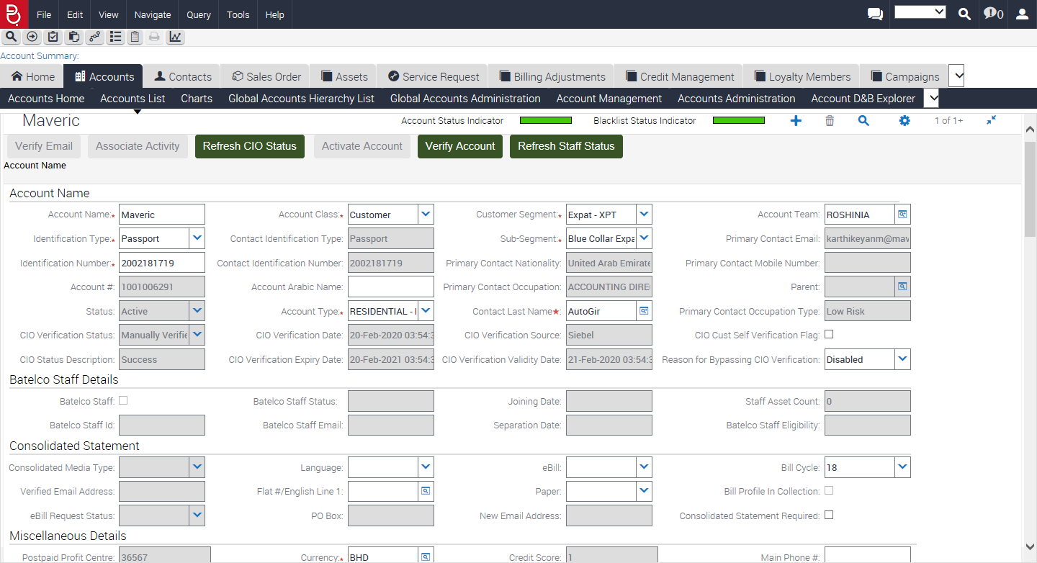

Installed Asset Detail

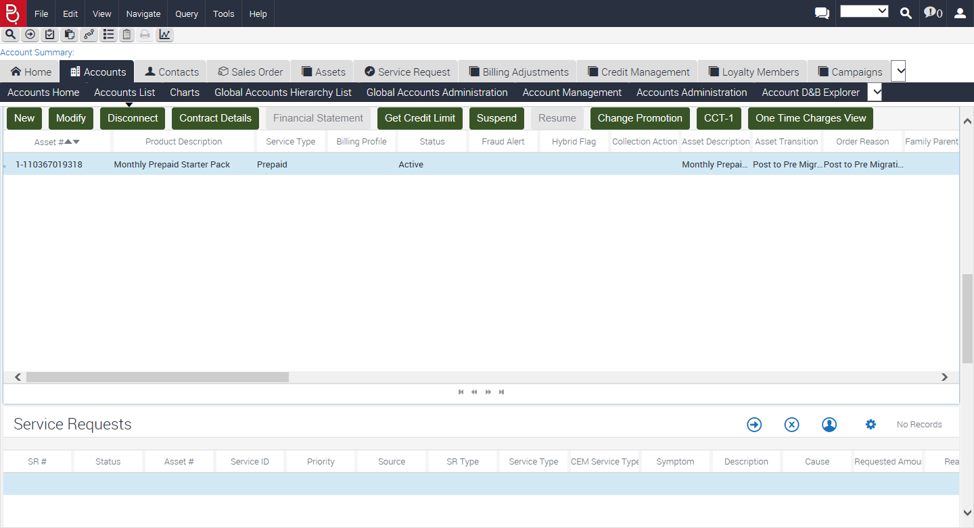

BatelcoPostToPreMigration Successful



PostToPreMigration Event is Passed for Account Number: 1001006291 and Order: 20020000321 is submitted Successfully and New Prepaid Number 8999999200027860059 Updated Successfully and Order Payment is Successfully completed : Complete and Order Completion Time: 1 minutes, 23 seconds.



Logout Successful

